Drawing tools

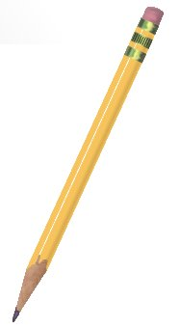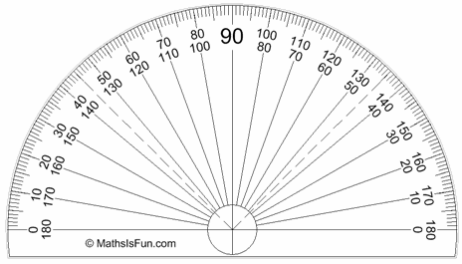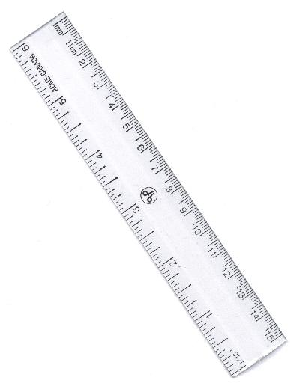

Jack buys three pencils. He pays 45p.

Mimi buys a pencil and a ruler. She pays 35p.

Peter buys a ruler and a protractor. He pays 41p.

How much would Eva pay for two pencils and a protractor?

